**Van Lang University**

**Information Technology Department**

**Software Engineering**

**Software Measurement And Analysis**

**Team Assignment 10**

**Greedy Shark Team**

**Team 16 – K15T1**



**Risk Management**

**Viking project**

**Team members**

|  |  |  |  |
| --- | --- | --- | --- |
| **#** | **Team members** | **Student ID** | **Mail** |
| 1 | Trần Hoàng Long | T093686 | [tranhoanglong.k15t@gmail.com](mailto:tranhoanglong.k15t@gmail.com) |
| 2 | Bùi Huỳnh Kinh Luân | T097430 | [buihuynh.kinhluan@gmail.com](mailto:buihuynh.kinhluan@gmail.com) |
| 3 | Nguyễn Minh Trí | T094328 | [00LanHikari00@gmail.com](mailto:00LanHikari00@gmail.com) |
| 4 | Trần Huỳnh Thái Trung | T096764 | [T096764@gmail.com](mailto:T096764@gmail.com) |
| 5 | Nguyễn Anh Tuấn | T096270 | [tuannguyen57v@gmail.com](mailto:tuannguyen57v@gmail.com) |

**Each team documents your risk management process, and applies your risk management approach to document the top 10 Viking risks.**

Table of Contents

1. Introduction 3

1.1. Document Summary 3

1.2. Defining Risk 3

1.3. Used Document 4

2. Software Risk Management 4

2.1. Data overview 4

# 1. Introduction

## 1.1. Document Summary

This article describes how risks associated with the Viking Project will be indentified, analyzed and managed. It outlines how risk management activities will be performed, recorded and monitored throughtout the lifecycle of the project.

## 1.2. Defining Risk

**1.2.1 Risk Definition**

A risk is an event or condition that, if it occurs, could have a positive or negative effect on a project’s objectives.

**1.2.2 Risk Management**

Risk Management is the process of identifying, assessing, responding to, monitoring and reporting risks.

Levels of Risk Management

* Crisis Management
* React to Failure
* Risk Mitigation
* Prevention
* Root Cause Elimination

Viking project will be executed by a following risk management process as mentioned below:

* Identify risks before they become issues or problems
* Analyze the risks and convert into decision-making information by computing impacts to

schedule, cost, quality and scope

* Develop risk mitigation plans for the risks
* Track the execution of risk mitigation process
* Control the execution of risk mitigation actions to ensure that the estimated costs do not outweigh the perceived benefits during execution
* Communicate the risks to various stakeholders at appropriate stages

Following diagram provides detailed risk management process for the Viking project management

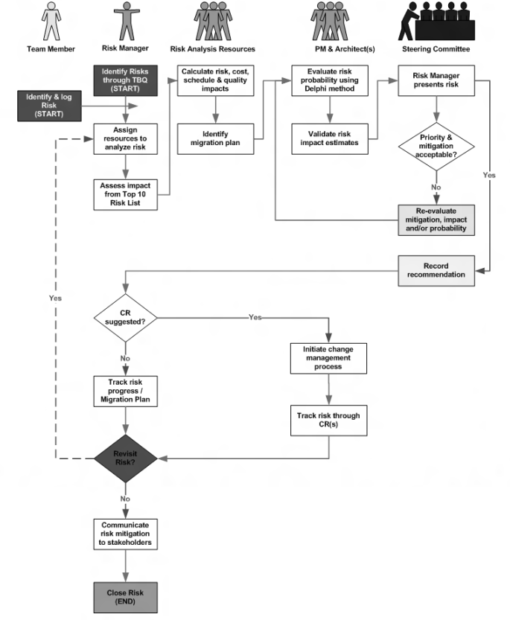

Risk Manager will lead the risk identification process. Known risks will be identified through

the issue logs and by allowing any project team member to notify risk manager of a perceived

risk.

The first step of our Detailed Risk Management Plan will be to generate a Top Ten Risk list.

The Risk Manager will interview all stakeholders and the Project Management team to solicit a

list of risks. Those will be evaluated, qualified and quantified using a Delphi ranking approach

where each contributor will provide their assessment of the probability of the risk occurring and

the degree if impact it will have. All of the input will be averaged and presented in the Steering

Committee meeting for their approval. The Top Ten list will be sent to all team members. This

list of risks will be periodically revisited by the Risk Manager and can be amended after any

change has been reviewed and approved by the stakeholders.

## 1.3. Used Document

# Some data in this article are collected from the following references

* Viking Project Plan 1.0

# 2. Risk Management

## 2.1. Data overview

Each risk will be ranked by the chance it may occur (probability) and the impact should it occur based upon a score of 1 to 5 where 1 has a 90 percent chance of occurring where 5 only has a 10 percent chance.

**Probability**

|  |  |  |
| --- | --- | --- |
| # | Probability | Meaning |
| 1 | 10% | Remote |
| 2 | 30% | Unlikely |
| 3 | 50% | Likely |
| 4 | 70% | High Likely |
| 5 | 90% | Near certainty |

**Impact**

* **Very High –** Risk that has the influence to the entire project, project maybe failed
* **High** – Risk that has the potential to greatly impact project cost, project schedule or performance
* **Moderate** – Risk that has the potential to slightly impact project cost, project schedule or performance
* **Low** – Risk that has relatively little impact on cost, schedule or performance
* **Very Low** – Risk that has the negligible impact on cost, schedule or performance

|  |  |  |  |  |
| --- | --- | --- | --- | --- |
| **Impact** | **H** |  |  |  |
| **M** |  |  |  |
| **L** |  |  |  |
|  | **L** | **M** | **H** |
|  | **Probability** | | | |

**Project objectives that risks impact on:**

* Cost
* Schedule
* Scope
* Quality

## 2.2. Risk Analysis

**2.2.1 Risk Identification (Top Ten Risks list)**

Refer the file Risk List.xlsx

**2.2.2 Risk Analysis Result**